11.reate a Static Website and Containerize, Build & Serve it using Docker. Tasks: 1. Create a Simple Static Website (index.html file) with basic HTML content. 2. Write/create a Dockerfile to serve the website using Nginx. 3. Build the Docker Image 4. Run the container: 5. Access the Website using a Browser

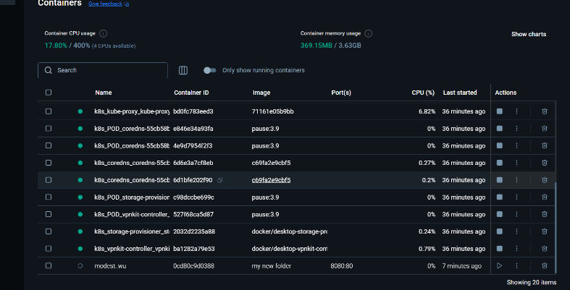

15 Create a GitHub Repository and Implement Version Control

Tasks:

• Set up a repository for a team project.

• Create branches for individual modules.

• Merge branches with pull requests after code reviews.

• Resolve conflicts during branch merging.

• Document the workflow using the README file.

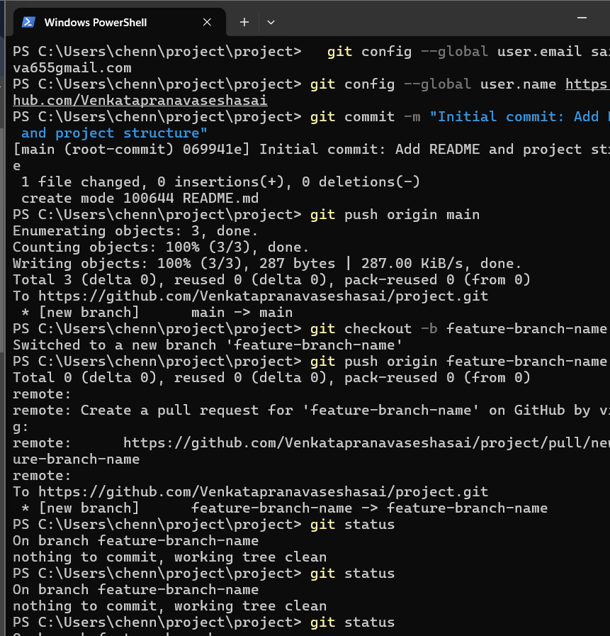

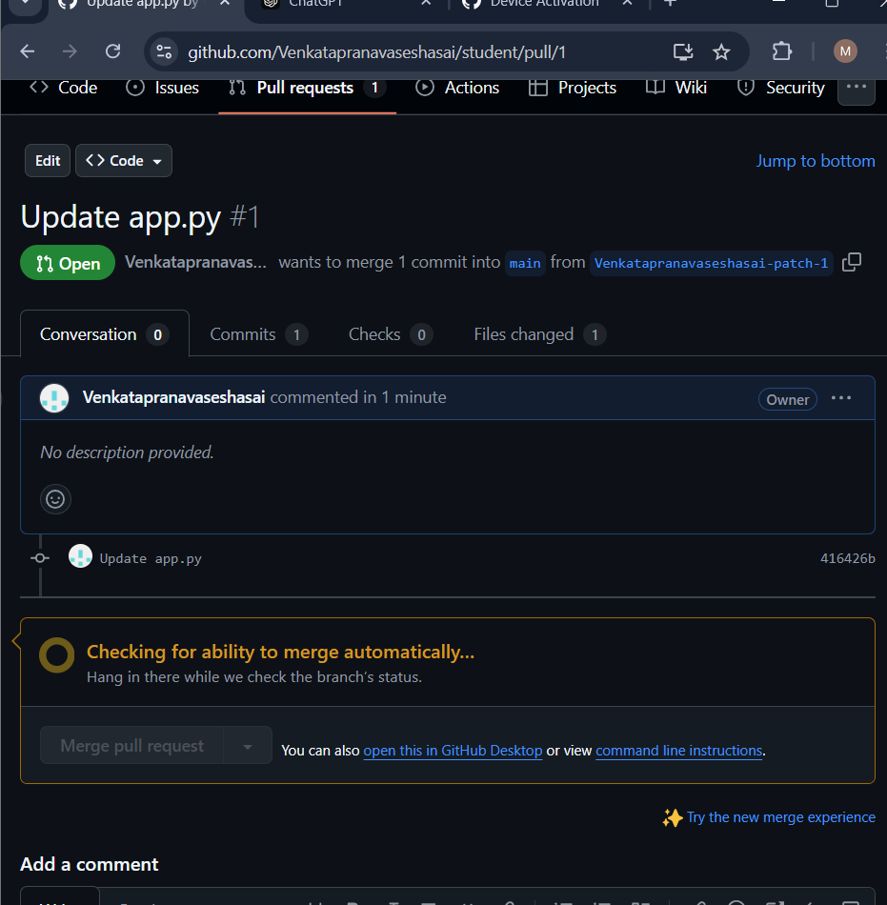

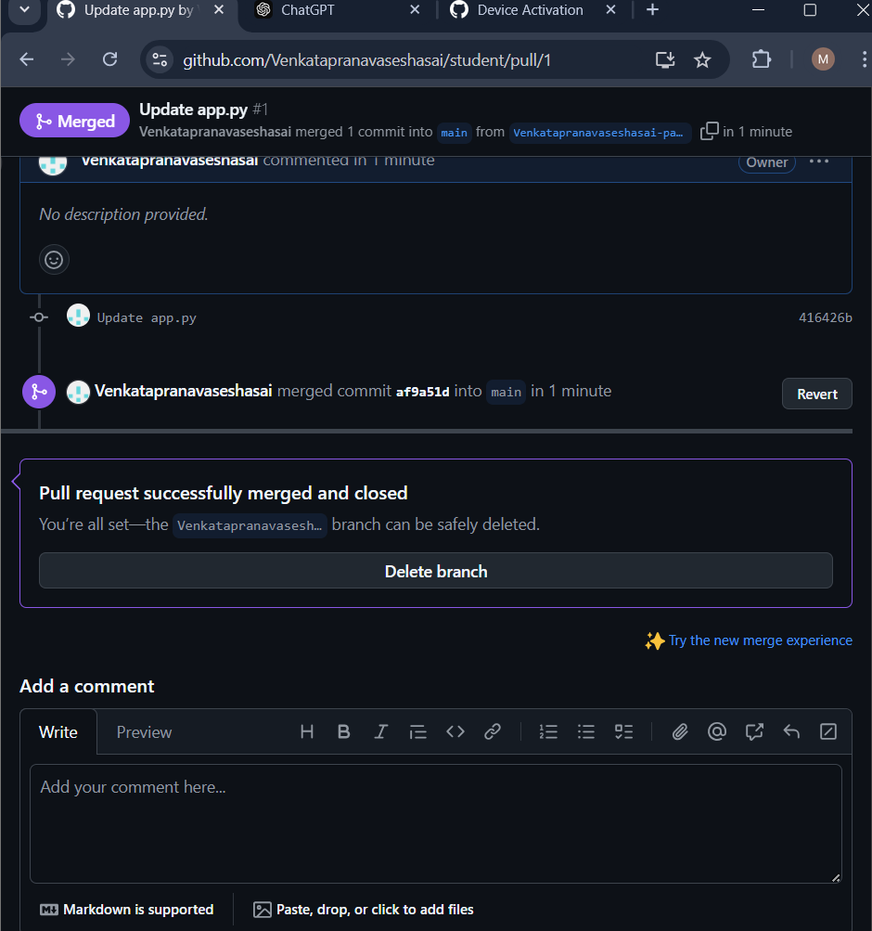

ou are tasked with developing an Online Learning Platform. The platform should include the following functionalities: 1. Course Enrollment and Registration 2. Video Lecture Streaming 3. Interactive Quizzes and Assignments 4. Progress Tracking Dashboard 5. Peer-to-Peer Discussion Forums 6. Certificate Generation Use Jira to categorize and prioritize these requirements using MoSCoW and Kano techniques.

